GitHub URL:
https://github.com/isa99sv/csd-402#

Java Connection Example:
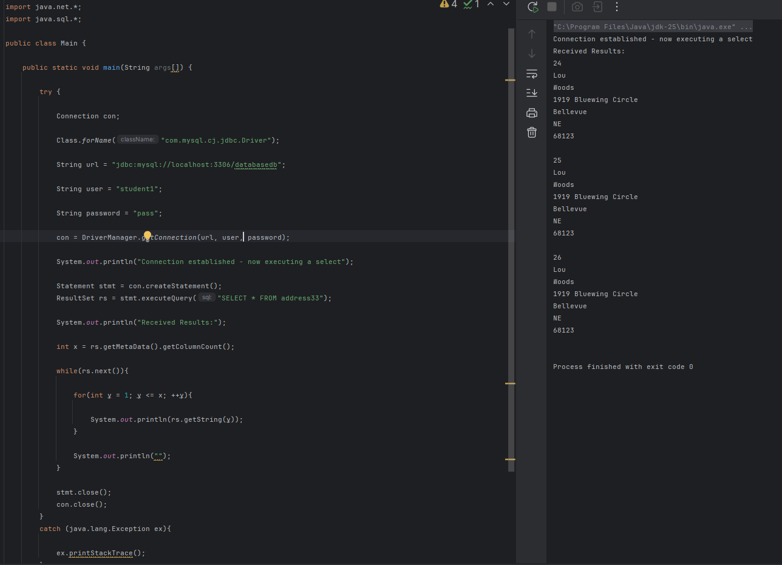

SQL Database Example:
